HOME AUTOMATION SYSTEM USING DYNAMIC HOST CONFIGURATION PROTOCOL (DHCP)

Submitted by

PULKIT SHARMA [RA2011003010136]

Under the Guidance of

Dr.T.K.SIVAKUMAR

Asst prof.(Sr.Grade) /Computing Technologies

In partial satisfaction of the requirements for the degree of

BACHELOR OF TECHNOLOGY
in
COMPUTER SCIENCE ENGINEERING

with specialization in CSE CORE



SCHOOL OF COMPUTING

COLLEGE OF ENGINEERING AND TECHNOLOGY
SRM INSTITUTE OF SCIENCE AND TECHNOLOGY
KATTANKULATHUR - 603203

NOVEMBER 2022



SRM INSTITUTION OF SCIENCE AND TECHNOLOGY
KATTANKULATHUR-603203

BONAFIDE CERTIFICATE

Certified that this lab report titled “Home automation system using Dynamic Host Configuration Protocol (DHCP)” is the bonafide work done by PULKIT SHARMA [RA2011003010136] who carried out the lab exercises under my supervision. Certified further, that to the best of my knowledge the work reported herein does not form part of any other work.

Staff-in-charge
Dr.T.K.SIVAKUMAR
Asst.Prof.(Sr.Grade) / Computing Technologies

ABSTRACT

The main objective of this project is to develop a low-cost secure Home automation system using Dynamic Host Configuration Protocol (DHCP) which can be remotely controlled by a device on any network.

As technology advances, we are seeing the advent of automation even in our daily lives. Modern houses are gradually shifting from conventional switches to centralized control system, involving remote controlled switches.

Presently, most appliances need to be operated in person by user which makes it cumbersome, time wasting and redundant at times. It becomes even more difficult for the elderly or physically handicapped people to do so. Automation system provides an efficient and modern solution to manage this. Here we apply this method to automate our House.

In order to achieve this, a wireless Home Gateway is connected to Servers Via Internet using DHCP so we can operate Devices at home from anywhere, a GUI application on the cell phone sends ON/OFF commands to the receiver to which devices are connected. By using DHCP to automate the process of configuring devices on IP networks, thus allowing them to use network services such as DNS, NTP, and any communication protocol based on UDP or TCP, the devices can be turned ON/OFF remotely through devices connected over the Server. Thus, we connect and operate devices over the internet via the Dynamic Host Configuration Protocol.

ACKNOWLEDGEMENT

We express our heartfelt thanks to our honorable Vice Chancellor Dr. C. MUTHAMIZHCHELVAN, for being the beacon in all our endeavors.
We would like to express my warmth of gratitude to our Registrar Dr. S. Ponnusamy, for his encouragement
We express our profound gratitude to our Dean (College of Engineering and Technology) Dr. T. V.Gopal, for bringing out novelty in all executions.
We would like to express my heartfelt thanks to Chairperson, School of Computing Dr. Revathi Venkataraman, for imparting confidence to complete my course project
We wish to express my sincere thanks to Course Audit Professor Dr.Annapurani Panaiyappan, Professor and Head, Department of Networking and Communications and Course Coordinators for their constant encouragement and support.
We are highly thankful to our my Course project Faculty Dr. T.K Sivakumar, Asst.Professor, CTECH , for his assistance, timely suggestion and guidance throughout the duration of this course project.
We extend my gratitude to our HOD,Dr. Pushpalatha M, CTECH and my Departmental colleagues for their Support.
Finally, we thank our parents and friends near and dear ones who directly and indirectly contributed to the successful completion of our project. Above all, I thank the almighty for showering his blessings on me to complete my Course project.

TABLE OF CONTENTS

CHAPTERS CONTENTS PAGE NO.

1. INTRODUCTION 08
2. REQUIREMENT ANALYSIS 12
2. ARCHITECTURE & DESIGN 13
4. IMPLEMENTATION 16
5. EXPERIMENT RESULTS & ANALYSIS 17
6.1 RESULTS 17
6.2 RESULT ANALYSIS 20
6.3 CONCLUSION & FUTURE WORK 21
7. REFERENCES 22

CHAPTER-1
INTRODUCTION

Nowadays, we have remote controls for our television sets and other electronic systems, which have made our lives really easy. Have you ever wondered about implementing the same on our home automation which would give the facility of controlling tube lights, sensors, fans and other electrical appliances at home using a remote control? Of-course, Yes! We have built a system called Smart Home Networks Monitor Using DHCP. This system is a cost effective and efficient way to give a user, the ability to control any home appliances over the servers.
To implement this System, we use Dynamic Host Configuration Protocol (DHCP) to automate the process of configuring devices.
The Dynamic Host Configuration Protocol (DHCP) is a network management protocol used on Internet Protocol (IP) networks for automatically assigning IP addresses and other communication parameters to devices connected to the network using a client-server architecture. A DHCP server dynamically assigns an IP address and other network configuration parameters to each device on a network so they can communicate with other IP networks.
The IP addressing plan is optimized in DHCP: addresses no longer being used are freed up and made available to new clients connecting and User mobility is easily managed in DHCP: the administrator doesn’t need to manually reconfigure a client when its network access point changes.
The technology eliminates the need for individually configuring network devices manually, and consists of two network components, a centrally installed network DHCP server and client instances of the protocol stack on each computer or device. DHCP options can be used to automatically provide clients with information on the network services it can use. This is a very efficient way to push the IP address of the time server, the mail server, the DNS server and the printer server.
DHCP can be implemented on networks ranging in size from residential networks to large campus networks and regional ISP networks. Many routers and residential gateways have DHCP server capability. Most residential network routers receive a unique IP address within the ISP network. Within a local network, a DHCP server assigns a local IP address to each device.

Automation is a trending technology nowadays, here we use DHCP to implement a remote control over the electrical devices in a house. This system adds benefits to the traditional residents to monitor, control home appliances, and collateral save power from anywhere and anytime through Smart Phone. With the help of a GUI, we can control Home Devices from anywhere using Smart Phone as long as it is connected to internet.
Home automation is the residential extension of "building automation".
It is automation of the:
- Home
- Housework or
- Household activity.
Home automation may include centralized control:
- Lighting of entire house
- HVAC (heating, ventilation and air conditioning)
- Appliances and
- Other systems (Like Home Weather Station, digital receptionist, etc)

Home Automation (HA) provide improved convenience, comfort, energy efficiency and security

Bringing the Future Home: -

- Automate chores such as watering your lawn, opening and closing drapes, controlling your lights and appliances - even controlling your electric water heater.
- Use motion sensors to turn on floodlights and cameras outside your home. Or turn on lights indoors as you walk from room to room, create an automatic doorbell, and more.
- Use water sensors to inform you of leaking plumbing, both minor or major, while you're at home or away for the day or on vacation. (Why not have your Smart Phone call you to let you know?)
- Control your lights and appliances remotely via the Internet or a telephone
- Remotely adjust your thermostat so you can warm up your home before you get there.
- Save Energy by turning OFF unusual appliances.
- Set up a home surveillance system by using webcams.
- Security - monitoring doors and windows fire, smoke, water
For This Project we are using DHCP Protocol which is explained below: -

DHCP Introduction
- DHCP was created by the Dynamic Host Configuration Working Group of the Internet Engineering Task Force (IETF).
- Runs over UDP
- Utilizing ports:
- 67-connections to server
- 68- connections to client
- Extension of BOOTP (protocol used for simple interaction) - DHCP enhances the capabilities of BOOTP.
- DHCP temporarily binds IP address & other configuration parameters to DHCP client & provides framework for passing configuration information to hosts.
- DHCP was designed to provide computers with temporary address.
- DHCP is well adapted to situation where hosts move from one location to another or are routinely connected and disconnected.
- Thus, DHCP is mainly used to simplify the installation & maintenance of networked computers.
- Centralized IP address administration.
- Backward compatible with BOOTP - therefore a host running the BOOTP client software can request a static configuration from a DHCP server
- Supports multiple servers.
- Allows static assignment.
- Doesn't interact with domain name service (DNS).
CHAPTER-2
REQUIREMENT ANALYSIS

Software Used

Cisco Packet Tracer

Hardware Requirements

Processor

: 2.4 GHz Clock Speed

RAM

: 2GB

Hard Disk

: 500 MB (Minimum free space)

Software Requirements

Operating System : Windows 7

Platform : JavaScript, Python, Visual Blockly

Back End : MySql

Server : Apache Tomcat

CHAPTER-3
ARCHITECTURE & DESIGN

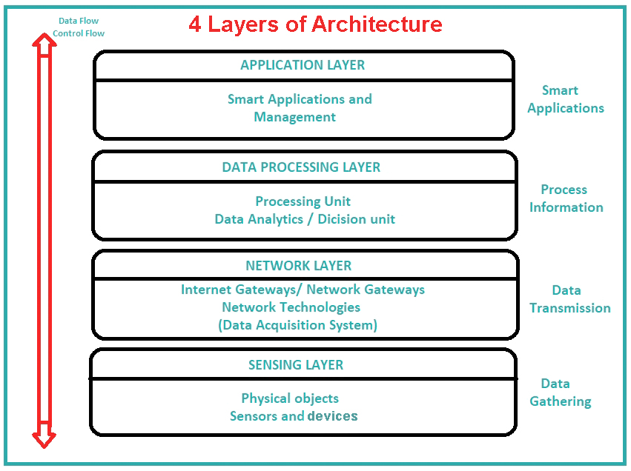
FIG 3.1

4 Layers of Architecture: -
- Sensing Layer – Sensors, actuators, devices are present in this Sensing layer. These Sensors or Actuators accepts data (physical/environmental parameters), processes data and emits data over network.
- Network Layer – Internet/Network gateways, Data Acquisition System (DAS) are present in this layer. DAS performs data aggregation and conversion function (Collecting data and aggregating data then converting analog data of sensors to digital data etc). Advanced gateways which mainly opens up connection between Sensor networks and Internet also performs many basic gateway functionalities like malware protection, and filtering also some time decision making based on inputted data and data management services, etc.
- Data processing Layer – This is processing unit. Here data is analysed and pre-processed before sending it to data center from where data is accessed by software applications often termed as business applications where data is monitored and managed and further actions are also prepared.
- Application Layer – This is last layer of 4 Layers of Architecture. Data centers or cloud is management stage of data where data is managed and is used by end-user applications.

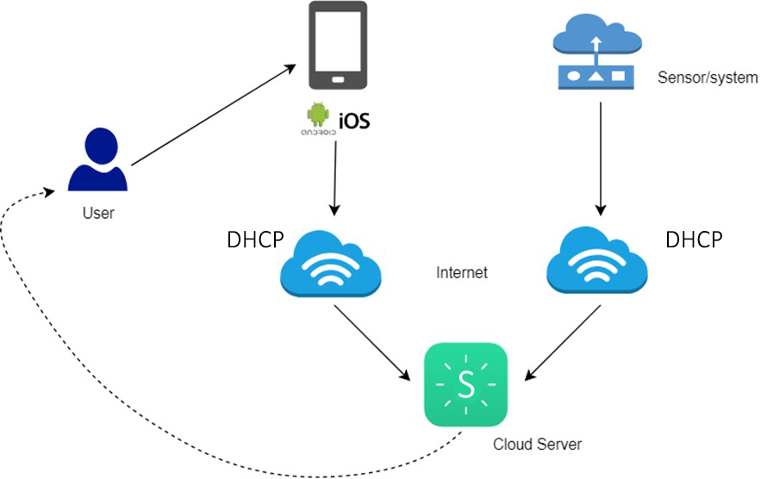
FIG 3.2
Working Diagram
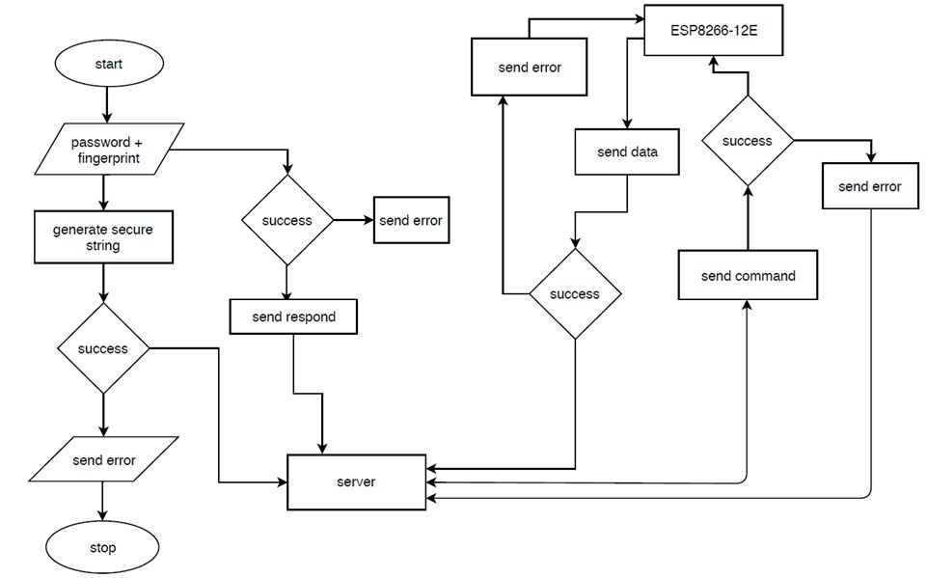
FIG 3.3
Flowchart For Smart Home Network

This Figure is providing idea of overall operation of the system. Initially the Android/IOS based Application checks for login credentials (Registration in server is Mandatary), If any kind of error is detected by the system, then it will indicate the ERROR status. If no error is found then the system will indicate the SUCCESS status and proceed for establishing the connection with the server. Then the server establish connection with the Home gateway. Now the system checks the modules as well as their connections, if any kind of error is detected by the system, then it will indicate the ERROR status. If no error is found then the system will indicate the SUCCESS status and proceed for establishing the connection with the local Wi-Fi. Here the system will again check whether the ESP8266-12E module is connected to the internet. If there is no connection then the system will indicate the ERROR status or else indicate SUCCESS status. Lastly ESP8266-12E module wait for the connection status from connected Home Devices and sensors, then the user is ready to use App accordingly to ON/OFF Devices.

CHAPTER-4
IMPLEMENTATION

- Step 1 - Using Cisco Packet Tracer Add Home Gateway to the Home Network
- Step 2 – Configure the Home Gateway Wireless Settings, i.e., here we Change SSID of Home Gateway to SMARTIOE and set its authentication mode as WPA2-PSK then set a Password.
- Step 3 - Connect Devices to the Wireless Network and configure them. Click the I/O Config tab and change the Network Adapter Type to the PT-IOT-NM-1W wireless adapter.
- Step 4 - Add End User Device to the Network. Click the Config tab and then click the Wireless0 Interface. Change the SSID from Default to SMARTIOE which is same as Home Gateway and its authentication to WPA2-PSK.
- Step 5 – Then we configure DHCP network from the ISP’s IOS Command Line Interface.
- Step 6 – We need to configure both the ISP Servers’ IP Configuration.
- Step 7 – Then we go to the devices’ configuration settings to set Server as Remote Server and Configure it using Server Address, User Name and Password.
- Step 8 – We can now register on the Device monitor from the Laptop and connect all devices to the Server.
- Step 9 – Now we can Control the registered Devices from the Monitor.
CHAPTER-5
EXPERIMENT RESULTS & ANALYSIS

RESULTS
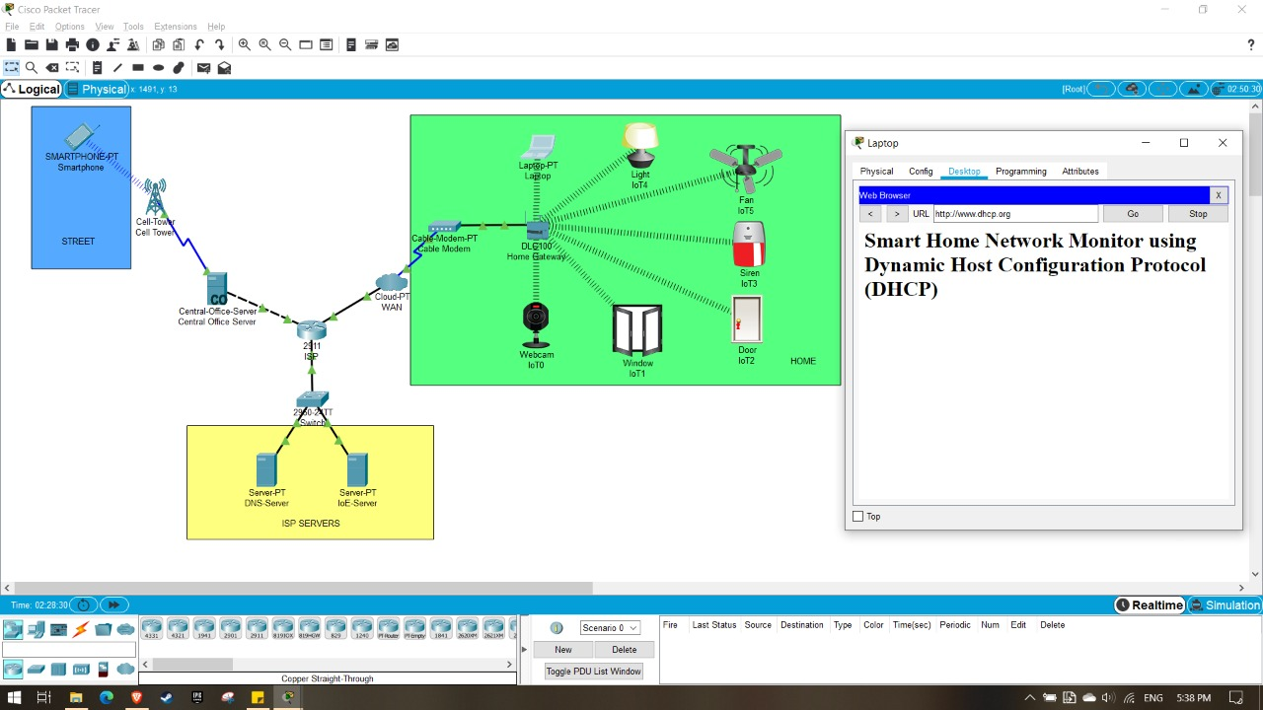
FIG 5.1
This figure depicts a working Smart Home Network Monitor System
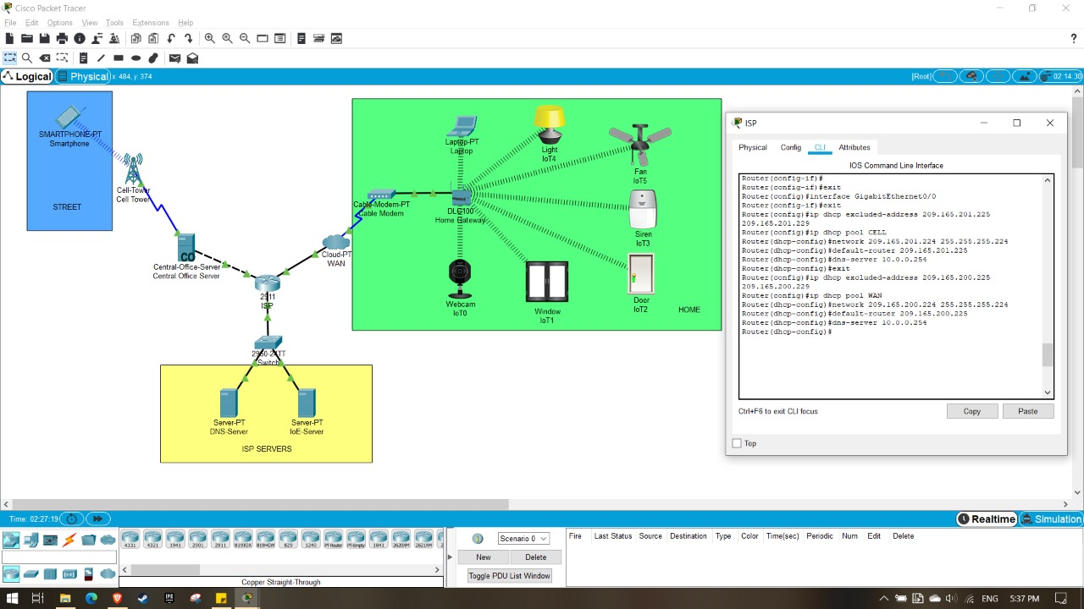
FIG 5.2
This figure depicts the configuration of the DHCP Networks.
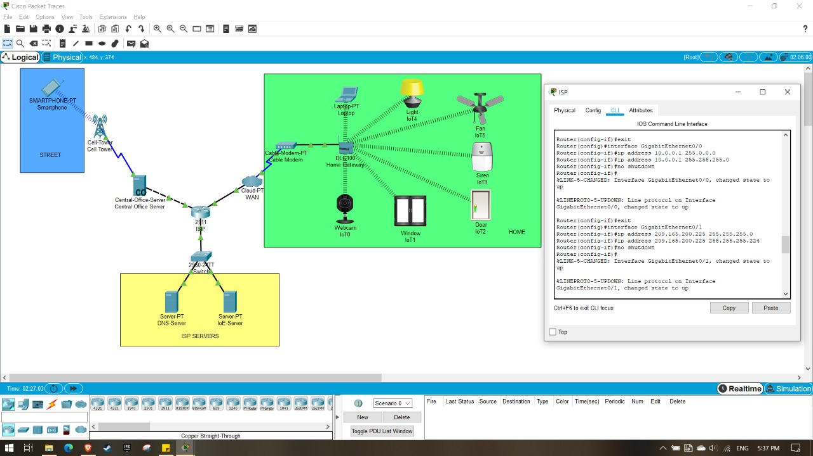
FIG 5.3
This figure depicts the configuration of the connections from ISP

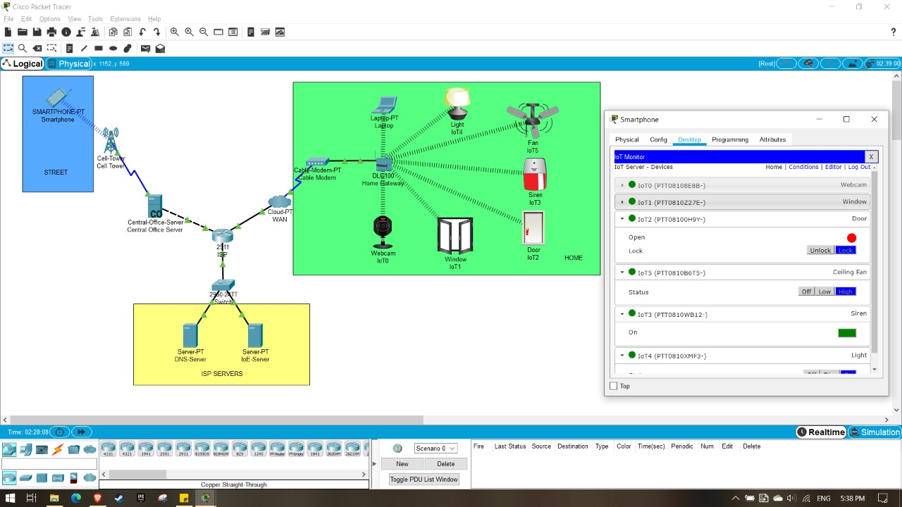
FIG 5.4
This figure depicts the Control Monitor being accessed from the Smartphone
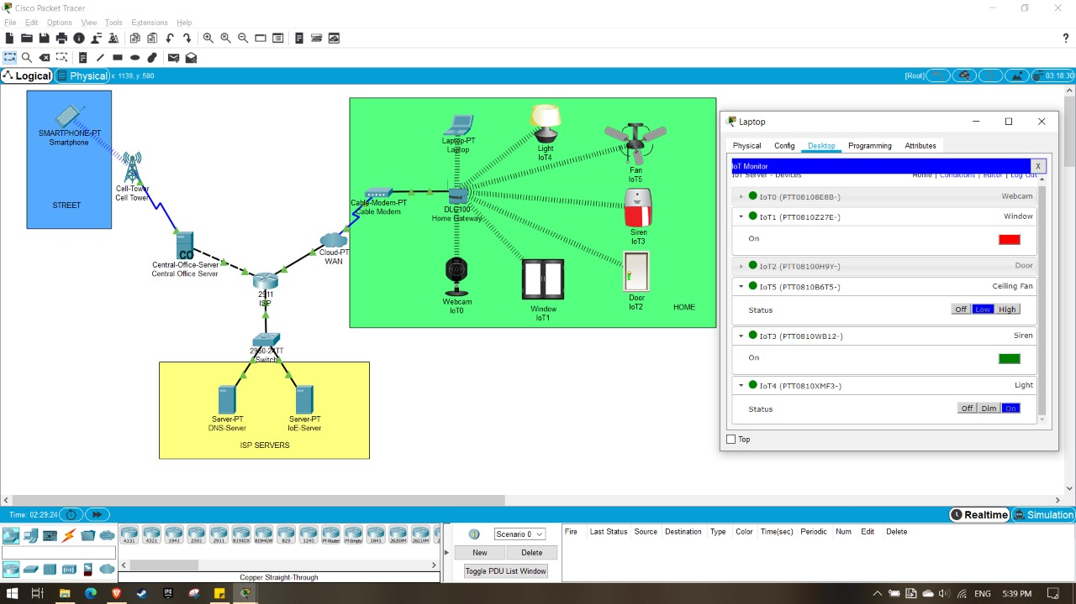

FIG 5.5
This figure depicts Control Monitor being accessed from the laptop.

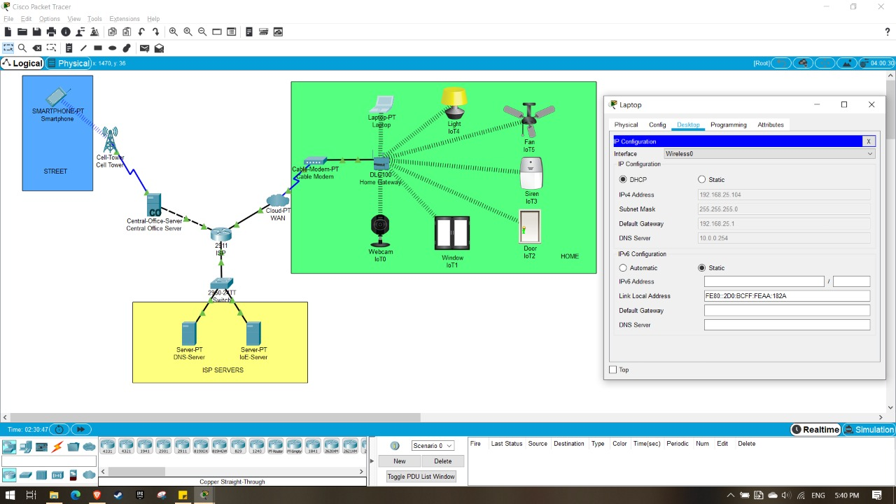
FIG 5.6
This figure depicts Ip configuration

RESULT ANALYSIS

We successfully implement a Home Network Monitor using a DHCP. Configuring router to connect the various components which make up our Home Automation System has been done which ensures control over the state of appliances across the internet on a single device. As we see in the pictures above, we can access our Network Monitor to control our appliances over different devices in this case Laptop and a Smartphone. We have connected the devices to the Home Gateway to access them. Our Home Gateway connects our circuit to the Modem which connects it to the Internet. Similarly, our Smartphone receiving and sending signals to the cell tower depicts its connectivity over the Internet which ensures our access to the devices connected to the Network even when we are not on the premises.

CONCLUSION & FUTURE WORK
CONCLUSION
- It presents an effective Smart Home Automation module.
- Advantages: -
- Cost effective
- Practically implementable
- Eco-friendly
- Energy Efficient
- Secure
- Disadvantage: -
- This module can’t be monitored remotely in the absence of Internet.

FUTURE WORK

Future Scope for the Home Automation Systems involves making homes even smarter. Homes can be interfaced with sensors including motion sensors, light sensors, smart door, smart windows, smart fan and smart home intrusion system and provide automated toggling of devices based on conditions. More energy can be conserved by ensuring occupation of the house before turning on devices and checking brightness and turning off lights if not necessary. The system can be integrated closely with home security solutions to allow greater control and safety for home owners.
The next step would be to extend this system to automate a largescale environment, such as offices and factories. Home Automation offers a global standard for interoperable products. Standardization enables smart homes that can control appliances, lighting, environment, energy management and security as well as the expandability to connect with other networks.

CHAPTER-6
REFERENCES

- D. Choi, S. Seo, Y. Oh, and Y. Kang, “Two-Factor Fuzzy Commitment for Unmanned IoT Devices Security,” IEEE Internet of Things Journal,vol. 6, no. 1, pp. 335–348, Feb 2019.
- M. H. Bhuyan, D. K. Bhattacharyya, and J. K. Kalita, Network Traffic Anomaly Detection and Prevention - Concepts, Techniques, and Tools,1st ed., ser. Computer Communications and Networks Series. Springer International Germany, 2017.
- R. Petrolo, V. Loscri, and N. Mitton, “Towards a smart city based on cloud of things, a survey on the smart city vision and paradigms,” Trans. Emerg. Telecommun. Technol., vol. 28, no. 1, pp. 1–12, 2015.
- S. P. Tseng, B. R. Li, J. L. Pan, and C. Lin, “An application of internet of things with motion sensing on smart house,” in IEEE International Conférence on Orange Technologies, 2014, pp. 65–68.
- S. Das, N. Debabhuti, R. Das, S. Dutta, and A. Ghosh, “Embedded system for home automation using sms,” in IEEE International Conference on Automation, Control, Energy and Systems, 2014, pp. 1–6.
- E. Yavuz, B. Hasan, I. Serkan, and K. Duygu, “Safe and secure pic based remote control application for intelligent home,” International Journal of Computer Science and Network Security, vol. 7, no. 5, 2007.
- A. Z. Alkar and U. Buhur, “An internet based wireless home automation system for multifunctional devices,” IEEE Transactions on Consumer Electronics, vol. 51, pp. 1169–1174, 2005.

